Final Movie Maker Project - Music Video Remake
For this final project, in groups of three, you will be creating your own music video to the song of your choice. For this project, instead of adding pictures to the project timeline, you would be adding individual movie clips that you have videotaped. You still may have a few pictures in your video if needed but the large majority of the music video must be actual video footage.

Requirements:
- Your video must be at least 2.5 minutes long. If you choose a very long song, you can opt to remove part of the song (ex. a verse or chorus). If you choose a song that is shorter than 2.5 minutes, you will need to repeat the chorus at some point or talk with me on ways to make your video longer in order to meet the requirements.
- If you edit or cut any part of the actual song, you need smooth transitions between those parts.
- Transitions between all movie clips are needed (unless discussed with me about a particular part) but must be subtle and not distractive.
- All group members must be equally present throughout the music video.
- All group members must lip sync to the words when being filmed.
- A title slide with the song name and artist is needed.
- Everything throughout the video must be school appropriate.

Because the timing of your actions when filming the video could become tricky as you record, it is highly advised that you have the actual song on an iPod or a phone so that you can listen to it before/during/after you are recording to make sure your actions are on cue with the song’s lyrics. If you choose to have the song playing as you are filming, you need to turn your recording device’s volume to low or silent or have it playing quietly so it can’t be heard in the actual taping.

Filming:
- You will be allowed to film your video throughout the school so be thinking of where you might want to do this.
- You may also choose to film parts of the video outside of school on your own time; there are quite a few days off school and various weekends coming up so keep those in mind.
- If you choose to film outside of school, you must have the clips with you at school during work time or something productive to do while the others are filming (other homework, videotape for other groups, etc.). You will not be allowed to just play games while others are working or your grade will be affected.
- Props, costumes, etc. are highly encouraged but not required.

Steps:
- Decide on your group members & which song your group will be using.
- Figure out where you will get the actual song itself to use when filming and for the project.
- Print out the lyrics of the song.
- Brainstorm what will be going on during each segment of your music video.
  - On your lyrics printout, write out a plan of what you will be “performing” and when.
  - If there already is a music video for the song your group chose, you CANNOT copy or mimic what the artist already did; you need to be creative and come up with your own original work.
- Begin filming the music video.
- Put the song and your video clips together in Movie Maker.

To Add Video Clips to Your Project

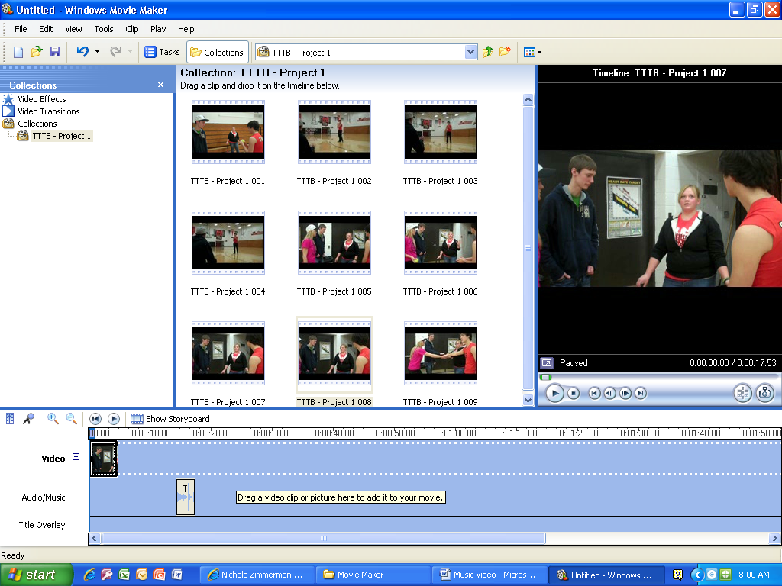
NOT HERE!
DRAG HERE!!

- Drag from the collections down to the Timeline.
- Make sure you drag down to the Video spot and not the Audio/Music spot.
- You may need your video clips converted to a different format. If that is the case, let me know.

