PowerPoint Notes #1

Purpose of a PowerPoint Presentation:
To act as a guide, supplementary tool, etc. during a presentation
It should not BE the entire presentation!

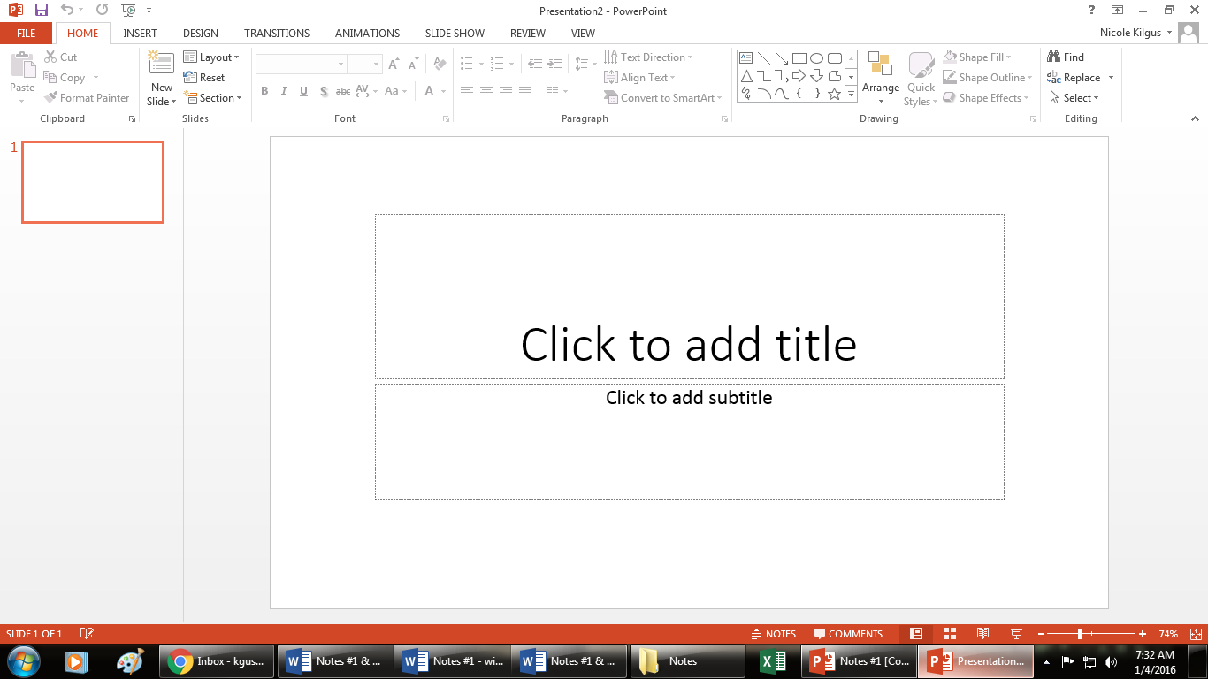

Slide Pane
3.

Slide Thumbnail
1.
Placeholders
5.

Slides Navigation Pane
2.

Fit Slide to Window
7.
Notes Pane
5.
View Shortcuts
8.

POWERPOINT RULES & EXPLANATIONS
- Light on Dark, Dark on Light
Use light text colors with dark backgrounds
Use dark text colors with light backgrounds

- 6 x 6 Rule
Only 6 bullets of text and only 6 words per bullet
This is the MAXIMUM; you may have less.
NO SENTENCES!
This prevents you from reading straight from the slides.
Only include keywords or phrases to trigger thoughts and ideas.
6x6 Exception . . . when using long quotations.

- Don’t overdo your Animations!
Animations are used to enhance your presentation, NOT to distract you from it!
Too many animations are confusing and very distracting.
DIFFERENT VIEWS, TABS, & THEIR ICONS
NORMAL VIEW
- Used to create the actual slides
- Able to add and edit text, objects, animations & transitions

SLIDE SORTER VIEW
- Displays all slides as thumbnails
- Allows you to easily click & drag the thumbnails when moving or rearranging them

SLIDE SHOW VIEW
- Allows you to run the slide show
- On Keyboard . . . F5 Key

READING VIEW
- Fills your PPT window with a preview of your presentation
- Has navigation buttons at the bottom right

NOTES PAGE VIEW SLIDE MASTER VIEW
- Notes added in Notes Pane will - Controls the formatting
Appear here on all slides
- Helpful during presentations - Changes made will
- Slide on top, notes are on the bottom appear on all slides
- Have to select to print as “Notes Pages” - Each Layout has a
layout master slide

OUTLINE VIEW HANDOUT MASTER
- An outline of your slide text will VIEW
appear in the slide navigation pane - Added information will
appear on sheets if you
print in handout form
NOTES MASTER VIEW
- Add text or formatting to appear on all of your printed speaker notes
TERMS
Transition: The way a slide appears on the screen

Animation: Motion given to text, objects, graphic, or pictures

Placeholders: Dashed, outlined boxes where information can be placed

Themes: Predesigned graphic styles
- Includes Color Scheme, Fonts, Formatting, Layouts, etc.

Layout: Where the placeholders for various objects are placed on a slide

Examples:

5 Ways to Add a New Slide
- Home Tab – Slides Group - New Slide Button – Choose a layout or click icon
- Click on a thumbnail in the Slides Navigation Pane – Enter (adds slide below the selected slide)
- Right Click on a thumbnail in the Slides Navigation Pane – New Slide option or Duplicate Slide
- Click on thumbnail – Ctrl M
- Insert Tab – New Slide Icon / Dropdown

2 Ways to Delete Slides
- Click on a thumbnail in the Slides Tab – Delete Key or Backspace
- Right Click on a thumbnail in the Slides Tab – Delete Slide option

To Apply a Theme
- Design Tab – Themes Group
- Variants Group: shows a variety of different looks using the selected theme
- Able to edit specific aspects of the theme in the Variants Group drop-down arrow

Applying a theme to a single slide:
  - When in the Themes Group, right click on a theme and choose “Apply to Selected Slides.”

3 Ways to Edit a Slide’s Background:
- Right Click – Format Background
- Design Tab – Background Group – Background Styles – Format Background
- Design Tab – Variants Group – Background Styles

The background can be any of the following options and can be edited within the Format Background Pane on the right:
- A Solid Color Fill - A Pattern
- A Theme - A Picture or Graphic file
- A Gradient Fill

What needs to be done if a picture/graphic is set as the slide background image?
- Change the transparency color of the text placeholder or text box

What needs to be done if you want a picture/graphic as the background but have a theme applied to that slide?
- Choose to “Hide Background Objects” when in the Background Dialogue Box

2 Ways To Change a Slide’s Layout:
- Right Click – Layout – Choose Layout
- Home Tab – Slides Group – Layout Button

To Apply a Transition to a Slide:
- Transitions Tab

How to know a Transition has been applied:
- A star next to the thumbnail
- The transition applied will be selected within the Transitions Group when you click on the slide

Two ways to advance to the next slide:
On mouse click Set a timer

Transition Rule:
- If bringing in a slide that will already have text on it, DO NOT bring it in from the top of the screen (bottom of slide comes down first) or from the Left of the screen (right side of the slide comes in first).

Notes #2 – Custom Animation

Steps to Adding Custom Animation:
- Animations Tab – click Animations Pane button to open it
- Insert object or type text
- Select (click on) object or text
- Animations Tab – Animations Group – Click on an effect OR click Add Animations Button and then choose an effect
- Effects will be listed in the Animations Pane

What are the four types of effects which can be added?

- Entrance
- Emphasis
- Exit
- Motion Paths

Three Options to Starting Your Effect
(drop down arrow next to affect in Animation Pane or next to Start in Timing group)
- On Click
- With Previous
- After Previous (given a time frame)

What two things show you that an effect has been added to your presentation?
- A small numbered box appears on the upper left corner
- The effect appears in the Custom Animation Task Pane

Right Click on the Effect in the Custom Animation Task Pane to:

- Change how the Effect starts
- Add Effect Options
- Change the Timing
- Remove the Effect

Effect Options:
- Additional options which can be added to some of the effects you chose

Additional Custom Animation Rule:
- If there is already text or pictures on a slide, animation should not come in overtop of that text/picture.

