Steps to creating Master Slides for the Question & Answer slides:
- Go to View – Slide Master

- Once in the Slide Master, they are going to delete all but three of the smaller slide thumbnails on the left. In the end, they will only have 4 thumbnails in all (1 larger, 3 small).

- For each of the three small thumbnails, they need to delete all of the text placeholders on the slides so that they are now completely blank.

- Next, right click on each of the small thumbnails and rename those layouts as the following:
1st thumbnail: Home Slide
2nd Thumbnail: Questions
3rd Thumbnail: Answers
Once finished renaming, when they hover over a thumbnail, they should be able to see the new layouts’ names.

- Go to the Answers Layout and insert an Action Button somewhere on the slide. They need to link that Action Button to the “First Slide”. This will be the button that takes them back to the Home slide after answering a question. Either right now or later, they need to format the color, outline, etc. of the action button; it can’t just be the default blue color.

- They should modify the background colors of all three layouts. All three layouts must have different backgrounds.

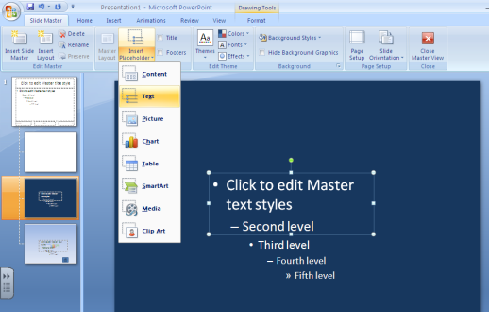
- They need to put text placeholders in the middle of both the Question and Answer layouts so the questions and answers are the in same general location (middle of the slide) on all slides. To do this they should go to the Slide Master Tab – Master Layout Group – hit the drop down arrow for Insert Placeholders – choose Text. They can change the font color, style, etc. of the text in here and then it will be the same on all slides. Reminder, if there is a dark background, use light text and vice versa.
- Close out of the slide master view.

- Tell them to hit the drop down arrow for New Slide and now they should only see three options (Home Slide, Questions, Answers). Each time they need to put in a new question or answer slide, they should just choose one of those master layouts.

- Tell them if they decide to change the background colors, text fonts, text colors, etc. for their slides, they need to go back into the Slide Master View to do so.

